Segmentation of Liquid level in the vessel:

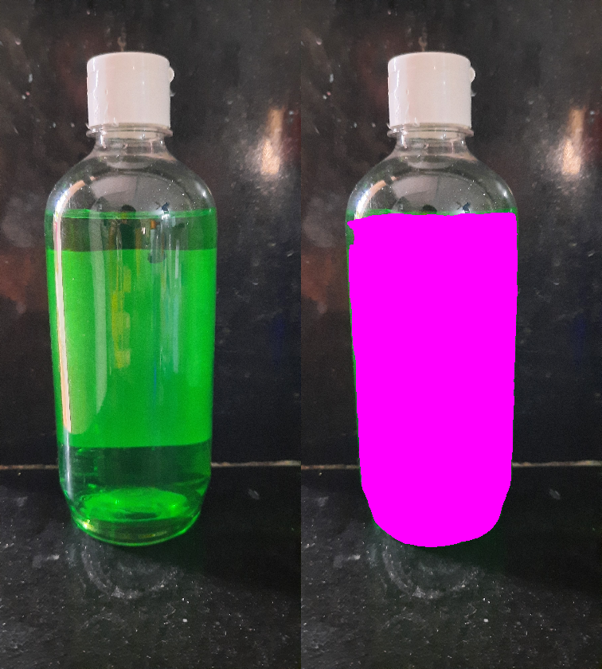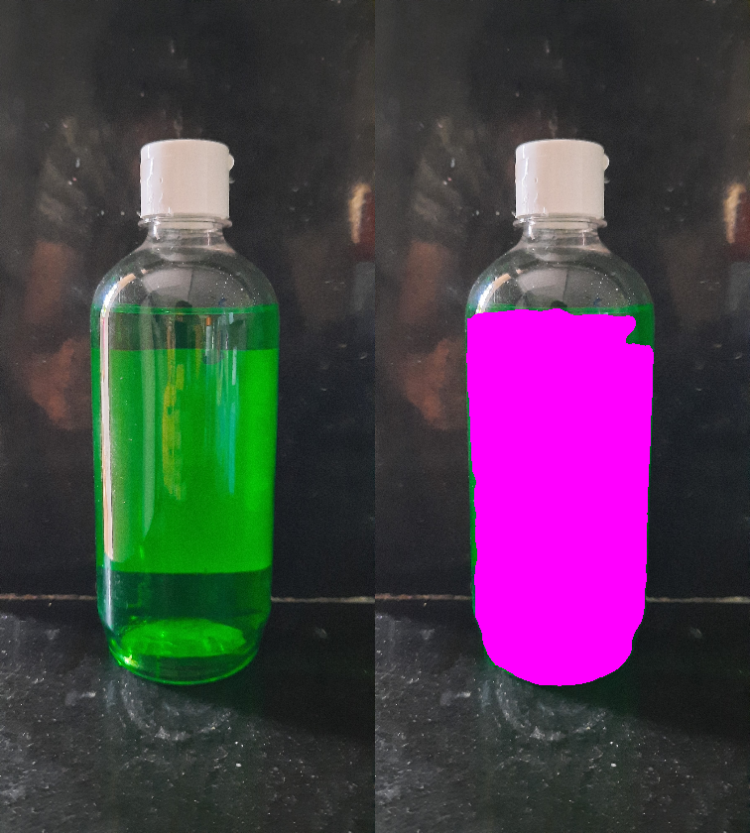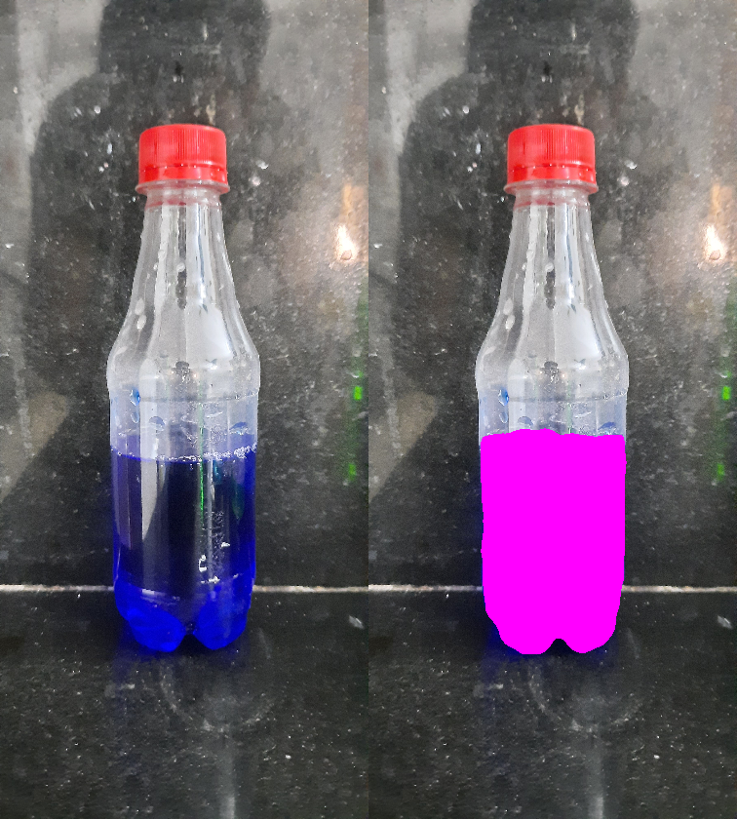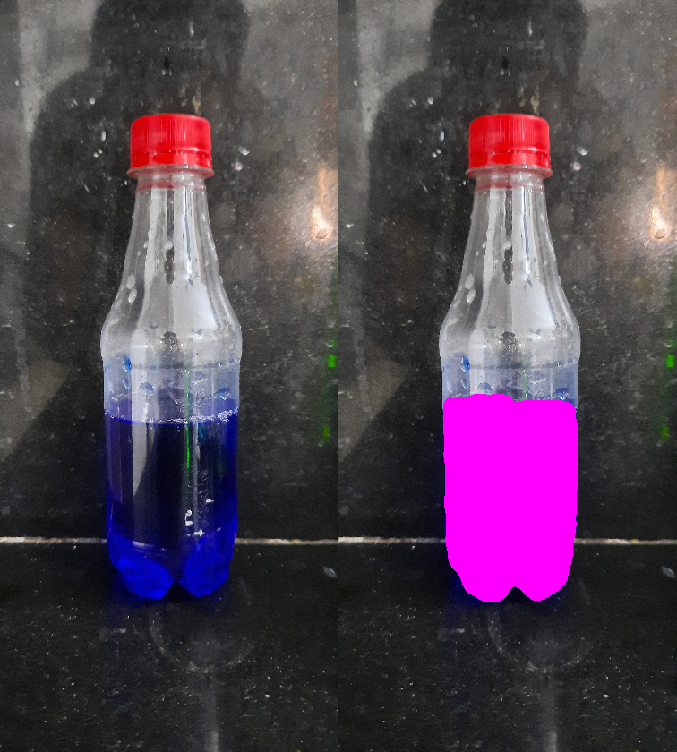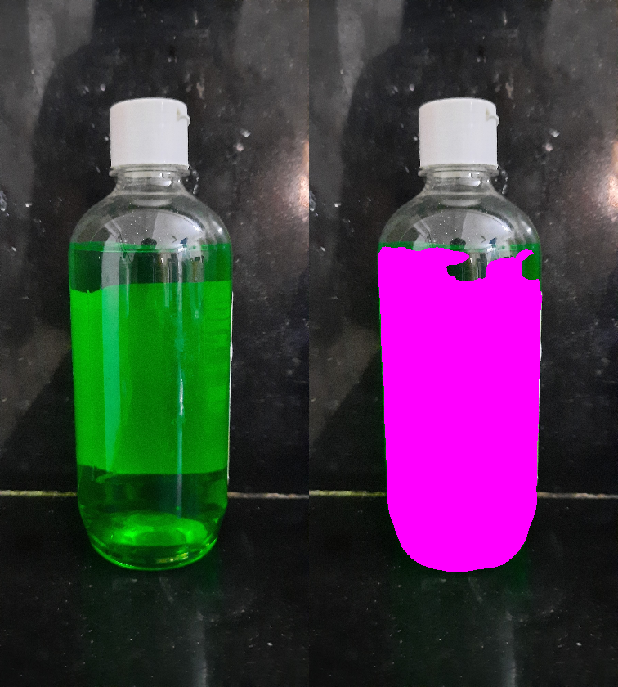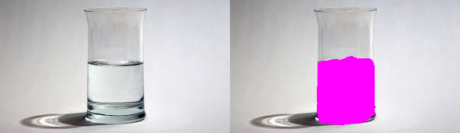

Segmentation of the vessel:

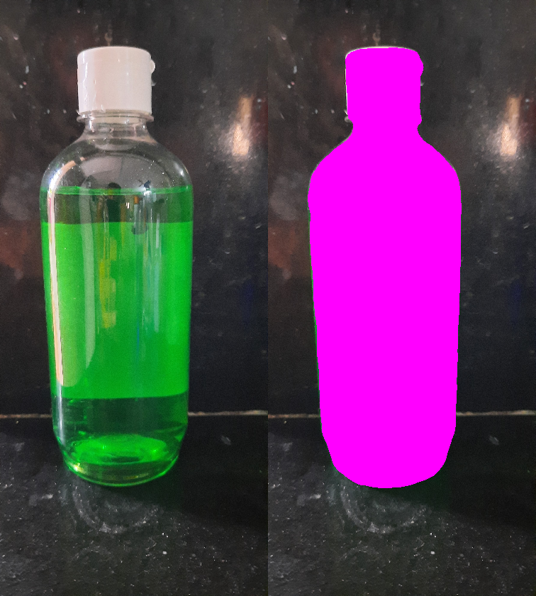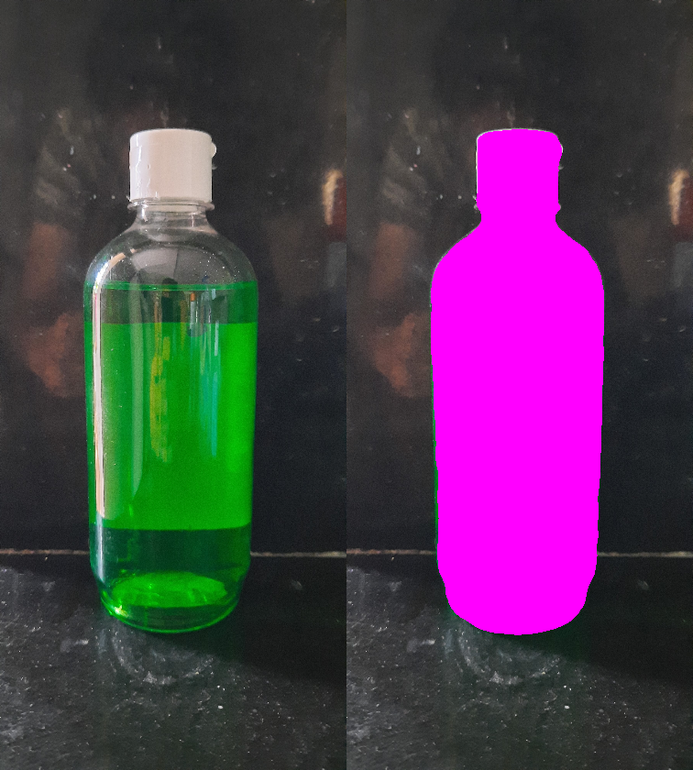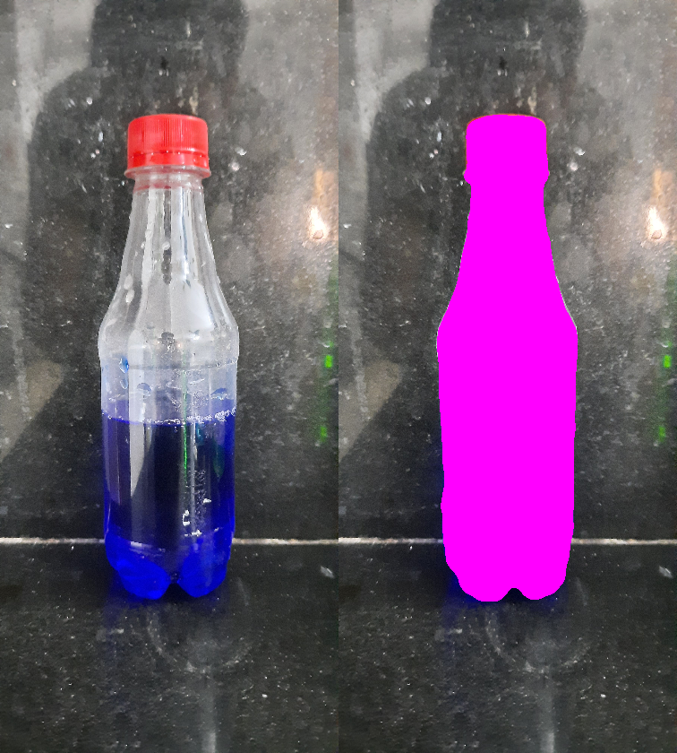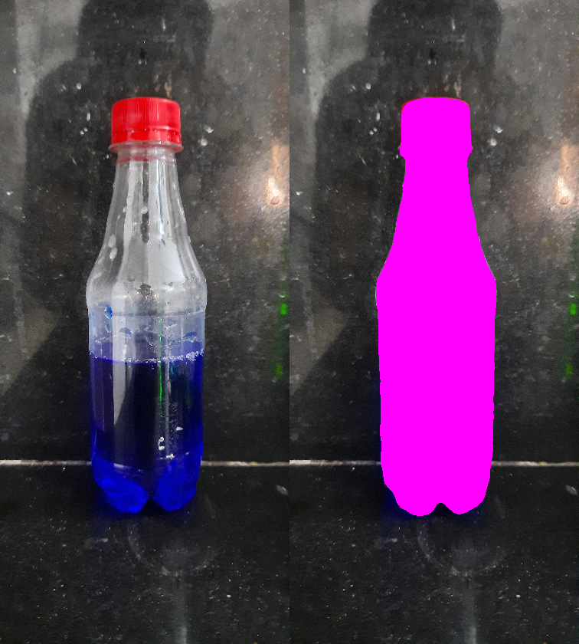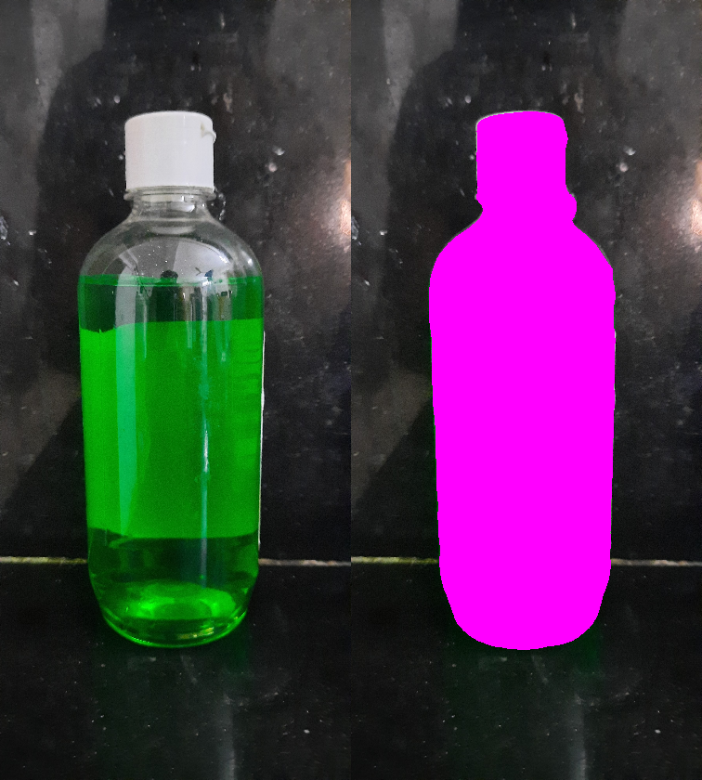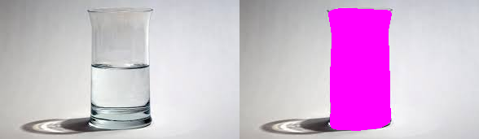

Idea:

Use computer vision for segmentation to detect the vessel and liquid inside it. The segmentation happens two folds:

1. First segmentation happens on the image to detect the vessel
2. Second, the segmentation detects the liquid inside the detected vessel area and marks it

Dataset used for training: [Vector-Lab Pics Dataset](https://www.cs.toronto.edu/chemselfies/) and [Coco Panoptic Dataset](http://cocodataset.org/" \l "download)

Model was based on: [Computer Vision on Chemical Lab Setting](https://chemrxiv.org/articles/Computer_Vision_for_Recognition_of_Materials_and_Vessels_in_Chemistry_Lab_Settings_and_the_Vector-LabPics_Dataset/11930004)

Requirements: Python 3.7(3.6.9 also works), PyTorch, OpenCV

Test Output with industrial images from Bajaj

Liquid detected:

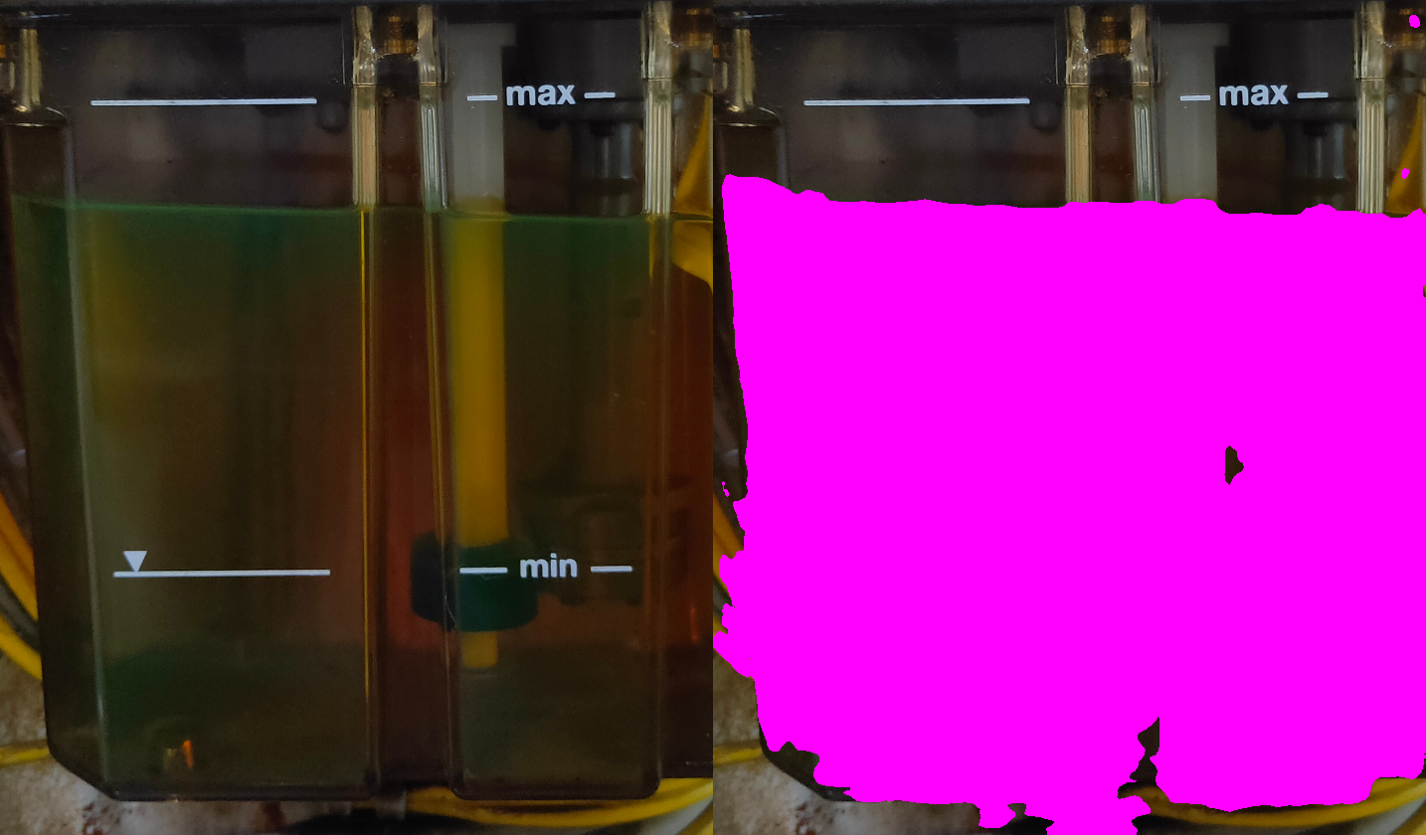

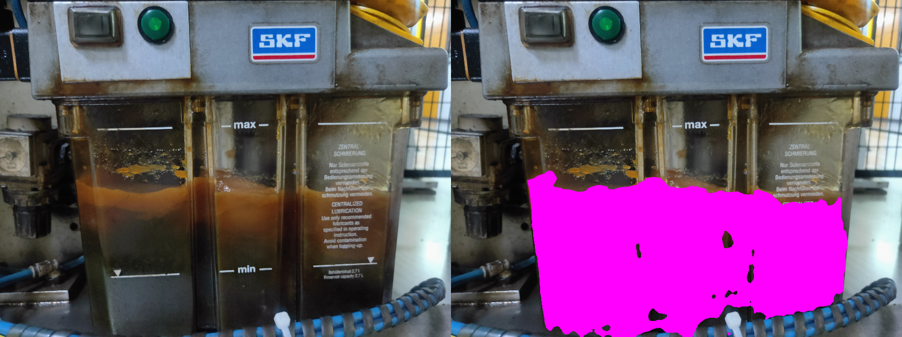

Vessel Detected:

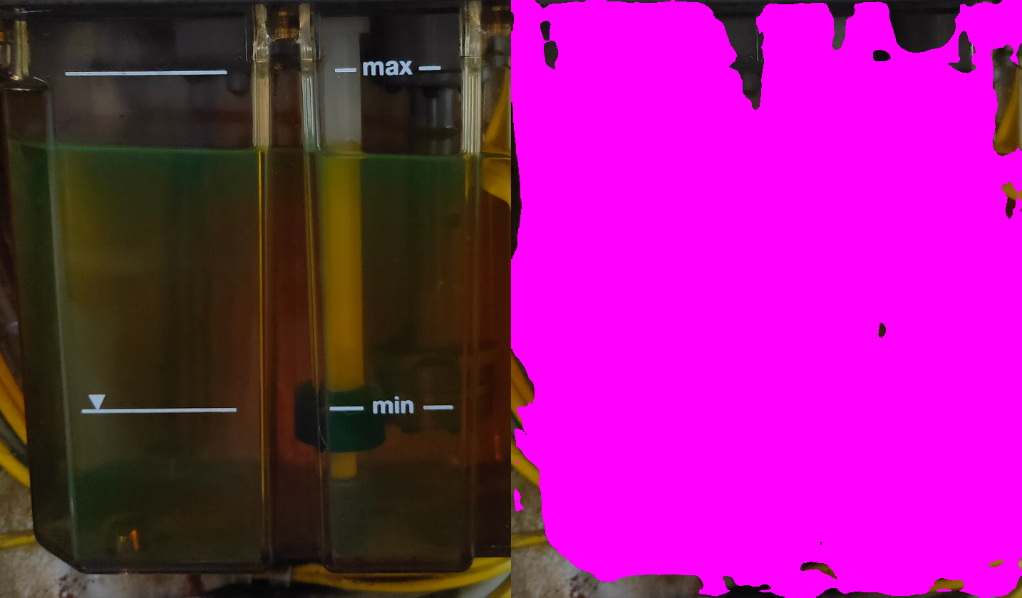

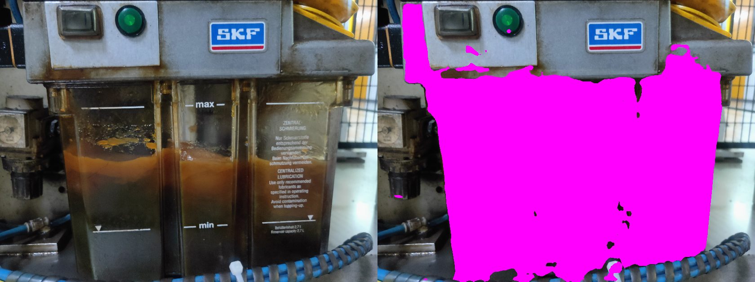

Version 2:

We count the number of pixels of the shaded as the output of the model. The values of shade is [255,0,255](RGB). We count the number of pixels in each image: Liquid level and vessel and take it’s ratio to give out a rough percentage.

Version 3:

We use object detection and optical character recognition on the images to detect the max and min marking in the vessel. Once the position is determined, we can overlay it on top of AR for more accuracy to detect the level of liquid filled.

Require more clearer images for model to work

Version 4:(Planned)